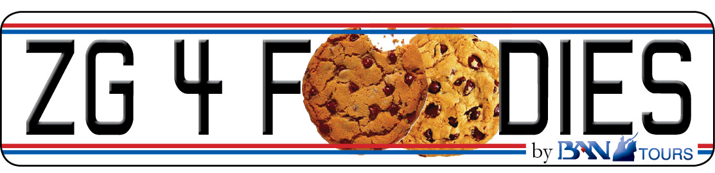

CROATIA - the new HOT SPOT 4 FOODIES. Be a trendsetter! Visit Croatia NOW, before the growing buzz attracts the tourist flocks.
The wine event of the year in Croatia, that shows that oenology and gastronomy are two essential parts of human creativity, will present more than 140 selected Croatian and international producers of wine and delicacies, gathering in total 600 wines.

Special workshops, wine tastings, cooking shows of renowned chefs and prominent guests are part of the exclusive programme of the Zagreb Wine Gourmet Festival 2011. Therefore the Festival is a meeting point not to miss for the professionals, hotel and restaurant F&B managers, wine buyers and distributors, specialised journalists, but also for the foodies looking for selected wines and top quality products on the market.

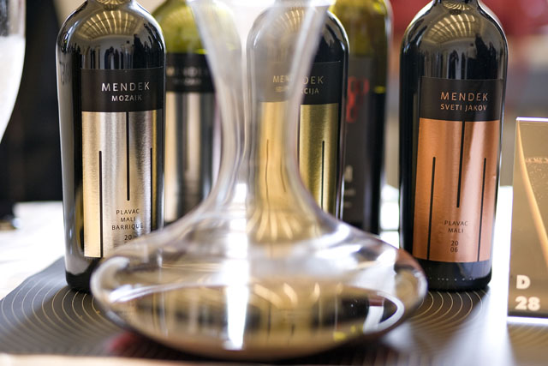  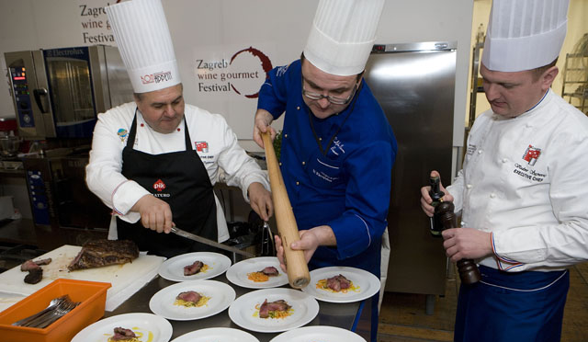  PRICE PER PERSON: | The 4th Zagreb Wine Gourmet Festival  February 25-26, 2011  Language: French, English, Italian, German  Min 2 persons – Max 10 persons  Program 3 Days / 2 nights (Friday – Sunday)  Day 01 ZAGREB Friday, 25 Feb  Meet and greet at Zagreb Airport followed by private transfer to the chosen hotel. Overnight.  Day 02 ZAGREB Saturday, 26 Feb  Breakfast buffet at hotel. The whole day reserved for attending The 4th Zagreb Wine Gourmet Festival according to the agenda. Voucher for dinner at selected restaurant. Overnight.  Day 03 ZAGREB Sunday, 27 Feb  Breakfast buffet at hotel and check out. Your guide will meet you in hotel lobby for Zagreb Gourmet Walking Tour. Start with Dolac – the most picturesque open air market in the city. In just few steps you will be in front of the Cathedral of St. Stephen and Archbishop's towers and halls. Following the Kaptol Square and neighboring streets you will get to famous Tkalciceva Street – pedestrian zone with plenty of cafés, restaurants, gourmet shops and galleries. The route will lead you further to stone pebbled Radiceva Street and The Stone Gate - remaining of strong city walls. Now, you will enter different, enchanting Zagreb returning back to 15th and 16th century. Step by step you will discover all major sights of Upper Town: St. Catherine's Square with baroque church, St. Mark's Square with House of Parliament, House of Government and St. Mark's Church with it's picturesque roof arriving panoramic spot beneath The Lotrscak Tower. Return to Lower Town by funicular.  Coffee break and sweet refreshment in Kraš Choco Bar – owned and managed by famous Croatian chocolate and sweets factory celebrating 100th anniversary.  Following the streets of Lower Town, passing Flower Square towards the Marshal Tito Square with three important landmarks of Zagreb: The Mimara Museum, Croatian National Theatre and Zagreb University. For the end of the tour you will follow the Lenuci’s “green horse-shoe” – 3 impressive squares and parks, passing the building of State Archives in Art-Déco style, Botanical Garden, and the Zrinjevac Park with a lot of buildings representing the typical architecture of Central Europe from the edge of 19th and 20th century. Buildings of The Croatian Academy of Science and Arts and neighboring Art Pavilion are two finest examples.  For the end of the tour you will taste famous Zagreb strukli (a pastry filled with mixture of cheese with eggs, sour cream and salt, covered in clotted cream and baked in oven) with a glass of wine in Le Bistro in The Regent Esplanade Hotel, a shining star at Zagreb gourmet scene.  Transfer to Zagreb Airport for outbound flight.  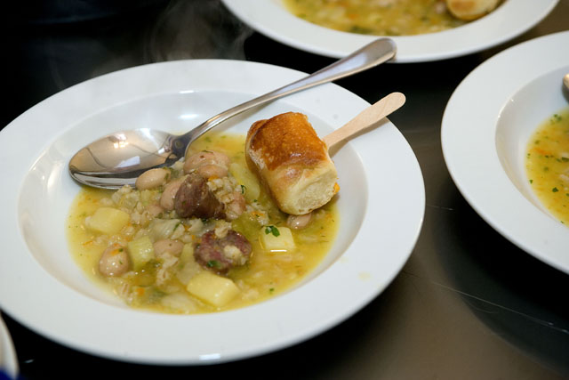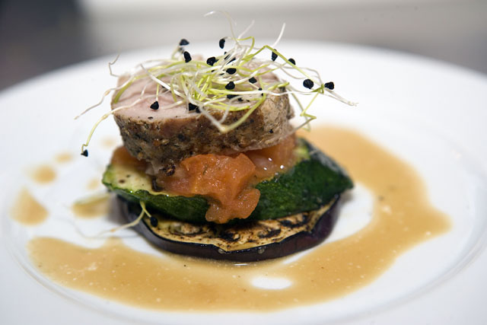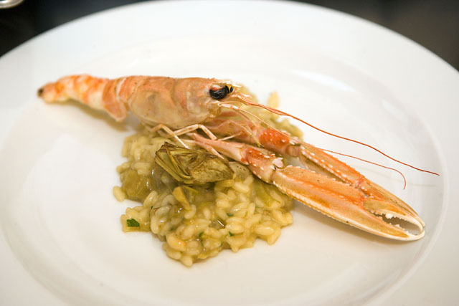
  Hotel | Room  Type | Number of persons
  Hotel | Room  Type | 2-3 | 4-6 | 7-10
  The Regent Esplanade | in dbl room | € 365 | € 350 | € 325
  The Regent Esplanade | sgl suppl. | € 140 | € 140 | € 140
  Palace Hotel | in dbl room | € 340 | € 325 | € 300
  Palace Hotel | sgl suppl. | € 90 | € 90 | € 90
  3 Days / 2 Nights Program includes:
  - Private R/T airport transfer
  - 02 nights at selected hotel based on BB sharing dbl/twn room
  - 01 Day Ticket / Sauturday for The 4th Zagreb Wine Gourmet Festival
  - Licensed City Guide for a Zagreb Gourmet Walking Tour according to
  the itinerary
  - Funicular ticket
  - Coffee and cake at Kraš Choco Bar
  - Snack (a pair of strukli – typical local meal, glass of wine)
  - 24/7 supervising by Ban Tours staff
  - VAT

BAN TOURS d.o.o. • Kaptol 11, 10000 ZAGREB • ID code: HR-AB-01-1-61509 • www.bantours.hr
Phone: +385 1 48 81 800 • Fax: +385 1 48 14 677 • e-mail: incoming@bantours.hr

CROATIA - the new HOT SPOT 4 FOODIES. Be a trendsetter! Visit Croatia NOW, before the growing buzz attracts the tourist flocks.
The wine event of the year in Croatia, that shows that oenology and gastronomy are two essential parts of human creativity, will present more than 140 selected Croatian and international producers of wine and delicacies, gathering in total 600 wines.

Special workshops, wine tastings, cooking shows of renowned chefs and prominent guests are part of the exclusive programme of the Zagreb Wine Gourmet Festival 2011. Therefore the Festival is a meeting point not to miss for the professionals, hotel and restaurant F&B managers, wine buyers and distributors, specialised journalists, but also for the foodies looking for selected wines and top quality products on the market.

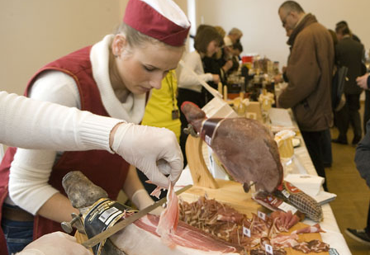  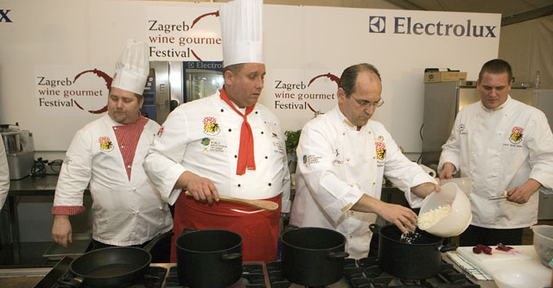  PRICE PER PERSON: | The 4th Zagreb Wine Gourmet Festival  February 25-26, 2011  Language: French, English, Italian, German  Min 2 persons – Max 10 persons  Program 4 Days / 3 nights (Thursday – Sunday)  Day 01 ZAGREB (arrival) Thursday, 24 Feb  Meet and greet at Zagreb Airport followed by private transfer to the chosen hotel. Overnight.  Day 02 ZAGREB Friday, 25 Feb  Breakfast buffet at hotel. The whole day reserved for attending The 4th Zagreb Wine Gourmet Festival according to the agenda. Overnight.  Day 03 ZAGREB Saturday, 26 Feb  Your guide will meet you in hotel lobby for Zagreb Gourmet Walking Tour. Start with Dolac – the most picturesque open air market in the city. In just few steps you will be in front of the Cathedral of St. Stephen and Archbishop's towers and halls. Following the Kaptol Square and neighboring streets you will get to famous Tkalciceva Street – pedestrian zone with plenty of cafés, restaurants, gourmet shops and galleries. The route will lead you further to stone pebbled Radiceva Street and The Stone Gate - remaining of strong city walls. Now, you will enter different, enchanting Zagreb returning back to 15th and 16th century. Step by step you will discover all major sights of Upper Town: St. Catherine's Square with baroque church, St. Mark's Square with House of Parliament, House of Government and St. Mark's Church with it's picturesque roof arriving panoramic spot beneath The Lotrscak Tower. Return to Lower Town by funicular.  Coffee break and sweet refreshment in Kraš Choco Bar – owned and managed by famous Croatian chocolate and sweets factory celebrating 100th anniversary.  Following the streets of Lower Town, passing Flower Square towards the Marshal Tito Square with three important landmarks of Zagreb: The Mimara Museum, Croatian National Theatre and Zagreb University. For the end of the tour you will follow the Lenuci’s “green horse-shoe” – 3 impressive squares and parks, passing the building of State Archives in Art-Déco style, Botanical Garden, and the Zrinjevac Park with a lot of buildings representing the typical architecture of Central Europe from the edge of 19th and 20th century. Buildings of The Croatian Academy of Science and Arts and neighboring Art Pavilion are two finest examples.  For the end of the tour you will taste famous Zagreb strukli (a pastry filled with mixture of cheese with eggs, sour cream and salt, covered in clotted cream and baked in oven) with a glass of wine in Le Bistro in The Regent Esplanade Hotel, a shining star at Zagreb gourmet scene.  Afternoon free at leisure. Voucher for dinner at selected restaurant. Overnight.  Day 04 ZAGREB Sunday, 27 Feb  Breakfast buffet at your hotel. Check out followed by private transfer to Zagreb Airport for outbound flight.
  Hotel | Room  Type | Number of persons
  Hotel | Room  Type | 2-3 | 4-6 | 7-10
  The Regent Esplanade | in dbl room | € 460 | € 445 | € 415
  The Regent Esplanade | sgl suppl. | € 210 | € 210 | € 210
  Palace Hotel | in dbl room | € 420 | € 405 | € 375
  Palace Hotel | sgl suppl. | € 130 | € 130 | € 130
  4 Days / 3 Nights Program includes:
  - Private R/T airport transfer
  - 03 nights at selected hotel based on BB sharing dbl/twn room
  - 01 Day Ticket / Sauturday for The 4th Zagreb Wine Gourmet Festival
  - Licensed City Guide for a Zagreb Gourmet Walking Tour according to
  the itinerary
  - Funicular ticket
  - Coffee and cake at Kraš Choco Bar
  - Snack (a pair of strukli – typical local meal, glass of wine)
  - 24/7 supervising by Ban Tours staff
  - VAT

BAN TOURS d.o.o. • Kaptol 11, 10000 ZAGREB • ID code: HR-AB-01-1-61509 • www.bantours.hr
Phone: +385 1 48 81 800 • Fax: +385 1 48 14 677 • e-mail: incoming@bantours.hr

